User Acceptance Testing

# Version 0.9.1 Beta Test

The First Version of the ADHD Task Manager Application released to beta testers was version0.9.1. We released the app to our testers with instructions on what and how we wanted them to test the application. It was designed so that the users would follow a set of instructions for that day before being able to do as they wish with the application for the rest of the day. The next day would see them refer to the instructions for more testing instructions before also being able to freely use the app again eventually. The instructions at the beginning of the user’s tests meant that we were able to go through specific use cases and features and was able to validate if they were working. Users would have the chance to list their concerns with how these use cases performed on their system.

The Free play that we encouraged our testers to do after completing that day’s instruction was also another opportunity for users to do more with the application in the hope that bugs and issues did present themselves.

## First Beta Testing Instructions

**Below is the exact copy of the beta testing instructions we sent out to our beta testers:**

Thank you for helping us Beta Test the ADHD Task Manager App. Beta testing means you will follow these instructions and answer these questions that will provide us with vital feedback to help improve the application before launch.

Below are some instructions on how we would like you to start the app each day. At the end of the instructions for that day, -Free Play- means you can use the app to your hearts content. Note: You can use some of the features that you have not used before. The more a user, uses the app, the more likely problems will present themselves.

If you come across any issues, in trying to complete one of the instruction tasks, please note down the instruction task you were trying to achieve, what happened and, if able, get a screenshot of the issue.

Please do the same if you come across any issues during free play.

After noting down the issue, proceed with the next instruction, if able.

The only thing we ask is that you start off each new day with the instructions for that day before playing with the rest of the app. Below the instructions are some questions, we would like you to answer.

**Please fill out the feedback form at this Google Forms link Friday 6th October:**

<https://forms.gle/n8NKuT7kLzrtEk3x7>

**How to Install the App:**

1. Click on this link to go to the sign on page. <https://play.google.com/apps/internaltest/4701147924381074666>
2. Go to the bottom and click “register to be a tester”
3. It will then say you have registered successfully. There is a link to download the app from the Play Store. Click on that link.
4. It will then take you to the Google Play Store. Tap on the install button to download and install the app.

**First Day (First Launch of the app)**

1. Log In with a Google Account.
2. Go to the Help Screen.
3. Go to Rewards Screen and check if there is a Log in Reward Achieved.
4. Create a new Task Todo.
5. Mark that task as complete.
6. Go To Rewards Screen and check if you earned the completed task reward.
7. Create another new task.
8. Edit the task to push the due date back by one day.
9. Delete that task.
10. Create another new task but set the due date and time 5 minutes from now.
11. Check for Notification on phone that task is due when the clock hits the due time.
12. Mark that task as complete.
13. Go To Rewards Screen and check if you earned the completed task reward.

-Free Play-

**Second Day**

1. Go to Rewards screen and check if log in reward was achieved.
2. Go the leaderboard screen and look at your points and position on the leaderboard.
3. Go to settings screen.
4. Toggle the Dark Mode and Light Mode.
5. Update your display name.
6. Update your country.
7. Update your profile picture.
8. Change the pomodoro work time to 2 minutes.
9. Change the pomodoro break time to 1 minute.
10. Go to the pomodoro timer screen. Start the timer.
11. Wait for work timer to complete then wait for break timer to complete.
12. Upon completion, start the timer’s again (Or Pause if it resumes).
13. Tap the pause button.
14. Tap the resume button.
15. Tap the stop button.
16. Go to the Home Screen
17. Create a new Task Todo.
18. Mark that task as complete.

-Free Play-

**Third Day**

1. Go to Rewards screen and check if log in reward was achieved.
2. Go the leaderboard screen and look at your points and position on the leaderboard.
3. Tap the Sign Out button.
4. Sign back in again.
5. Create a new Task Todo.
6. Mark that task as complete.
7. Go To Rewards Screen and check if you earned the completed task reward.

-Free Play-

**Feedback**

<https://forms.gle/hJqwGA2noRdWfynU8>

1. Please record any issues you come across during instructed actions or free play. This can be anything from the app crashing, to noticing some data is incorrect, or something is not being displayed how it should or was (eg writing or picture partly offscreen). When you find an issue, note down:

* What instruction you were trying to carry out.
* What you were doing when it happened, or you noticed it.
* How you remedied it or moved on (eg, restarted the app, or the app continued to function with the problem.)

1. After Completion of each day, what were some of the things you like about the app? (It could be the design, the usability, a feature) (If you have nothing more to add on the other days, that’s okay)
2. After completion of each day, what were some of the things you didn’t like about the app? (It could be the design, the usability, a feature. Really nitpick this one. Any little thing that annoyed you.) (If you have nothing more to add on the other days, that’s okay)
3. From Biggest problem to third biggest problem, what are the three biggest problems with the app? If you have more than three that you think really need addressing, note them down as well.

## First Beta Test Results

This section explores the feedback that was gathered from testers after the first round of out beta testing. This document includes the responses from our testers, as well as graphs to display common trends in the feedback from our testers.

## How the testers rated the applications UI

*The below graph is scale from unusable (1) to very usable (10).*

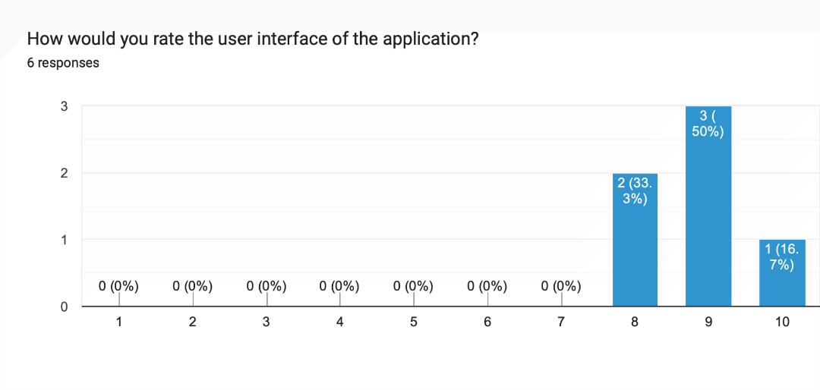

From a total of **six** responders, we can see the overall feedback from our testers is that the applications user interface was relatively well received. All our testers rated the applications user interface an 8 or above.

## How did the testers rate the performance of the application

*The scale of the graph below is from poor (1) to very good (10)*

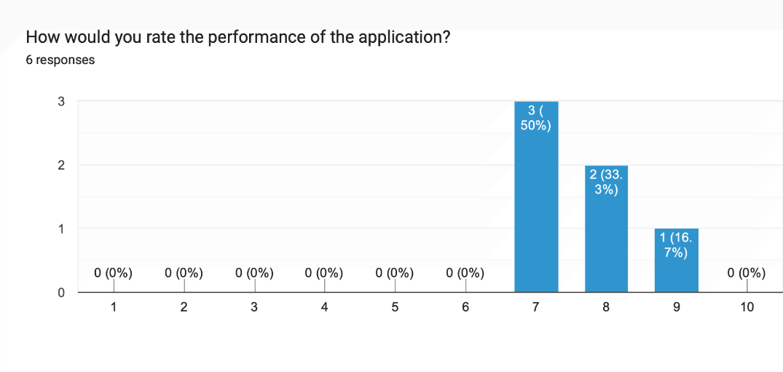

From a total of **six** responders, all of our testers rated the applications performance a 7 or above, indicating that the application performed well on our testers devices.

## How did the testers rate the functionality of the application

*The scale of the graph below is from Did not work as expected (1) to Worked as expected (5).*

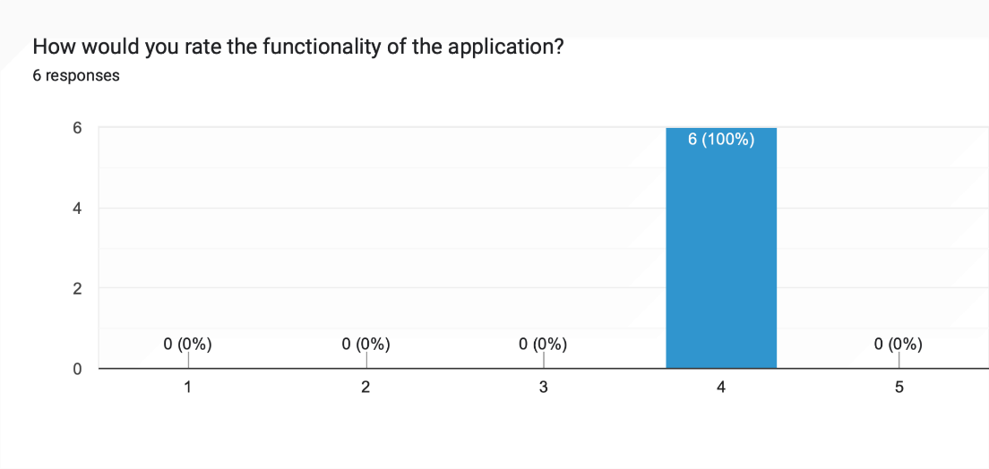

From a total of **six** responders, all our testers rated the applications functionality as a 4 out of 5, which indicates that our testers were largely happy with the functionality of the application, with some improvements that could be made.

## What our testers liked about the application

|  |
| --- |
| The designs colours were fun and the usability of the app was easy enough to pick up straight away. |
| I liked how clean the design was, nothing was cramped or overcrowded. |
| I liked the leaderboard incorporation, it was a fun way of interacting with the app and made me want to complete another task. |
| I liked the simplicity of the design |
| The design was nice, and easy to use. |
| I thought the app was really easy to use. The design also looked good. |

The feedback suggest that our tester felt that the application was easy to use, and that the user interface was clutter free, simple and visually appealing.

## What our testers did not like about the application

|  |
| --- |
| When first starting off I was unsure of what to click first. It took me a moment to find the help page to read how it works. A small helpful hint at the start would be nice on what to click. |
| Some parts of the app didn't change to dark mode when I toggled it on, in the completed task, rewards and leaderboard pages. The buttons for the timer were a little bit small for me. |
| I thought the adding a task page could be a little bit more aesthetic (the page that comes up when you have clicked the plus button. I felt like it didn't exactly match the aesthetic of the rest of the app. Maybe it should be a pop up over the home screen instead of a whole page. Also I feel the selecting a time for the task isn't very responsive. A scroll wheel for the time could be more appropriate. |
| Things I didn't like will be in my list of 3. |
| The welcome message popping up every time I opened the application, it would have been nice if it only did that the first time I opened the application for the day. The dark mode was a little broken on the leaderboard and rewards screens. |
| N/A. |

The feedback suggest that our tester felt that the application needed a tutorial or hint of how to navigate the application. The feedback also points out some inconsistencies with the UI, with the Add/Edit task UI not being consistent with the rest of the application. There were also several mentions of the dark mode not working correctly on a few of the screens.

## We asked our testers for three things they would like to see improved

*Our testers were asked to list three things that felt needed improvement in order of most to least important to them.*

|  |
| --- |
| 1- my reward didn't add up correctly. I had 7 task completion but 27 points.  2 - It took a me a while to figure out how to add a task the first time |
| 1. The dark mode on the rewards, completed and leaderboard pages.  2. Make the buttons on the timer page bigger.  3. A little tutorial when you first sign in that tells you how to add a task, that you can swipe to open and close the menu. |
| - The adding a task page  -The time feature on adding a task  - Signing out of the app crashed the app when trying to log back in |
| 1. Change the time setting from a clunky clock where users have to move the hands to one where they can just type their time.  2. Change the initial loading page to a few seconds shorter.  3. Fix the set out of words so the s isnt on another line. |
| 1. Make the welcome message only pop up the first time the app is opened per day.  2. Fix the dark mode on the leaderboard and rewards screens.  3. Maybe add a few more welcome messages so that there is a bit of variety. |
| I just have one thing I think could be improved, and that is to make some of the button a little bit bigger, such as the date, time buttons when making a new task. |

## Did our testers experience any bugs with the UI

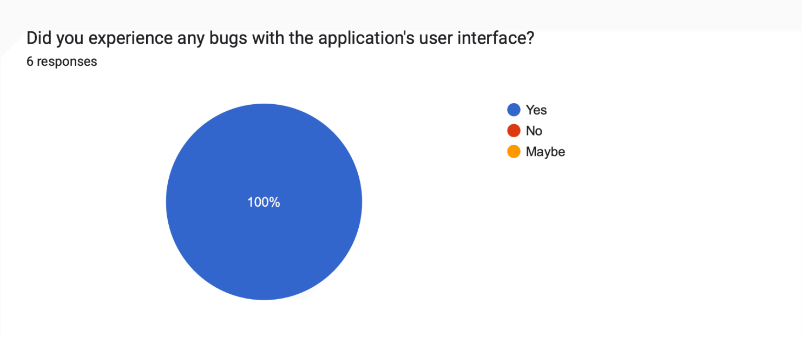

All **six** of our responders answered yes to this question, with their reasons explained by them in the responses below.

|  |
| --- |
| The rewards points didnt add up correctly. |
| The rewards points didn't match up with what I had earned by completing tasks and logging in. |
| The app crashed when on the first try of signing back in once I had signed out. |
| The rank page had a huge list one day of repeating users, but this changed when i logged out and back in. Also the settings would not display the full page, this was consistently happening after logging off. |
| The dark mode as mentioned in the previous section. |
| The rewards points didn't match what I should have had by completing the testing task. |

## Did our testers experience any crashes

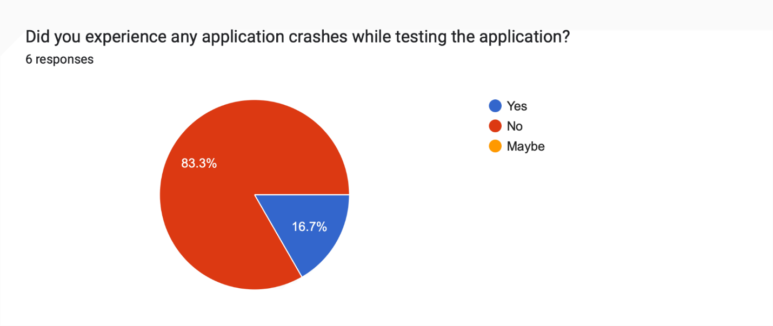

1 of our **six** responders responded yes to this question, with their reason explained in the response below.

|  |
| --- |
| The app crashed when on the first try of signing back in once I had signed out. |

## We asked our testers if they and any other feedback

We asked all our testers if they had any other feedback for us about the application, two of our testers responded with the following responses.

|  |
| --- |
| Great app, would definitely recommend to someone with the condition. |
| Matt will send you screenshots cos they won't attach here. |

## First Beta Test Fixes

As is expected in a beta test, there were some bugs to be found in the first beta version. Analysing the data gathered and cross referencing our Master Test Plan we decided on what the three major issues we would fix were.

In our Master Test Plan The following items were identified and marked with a severity on how important they were to be functioning correctly.

* Performance, Task Management, and Saving Task Data were given severity rank A, meaning the most important parts of the app.
* Usability, Reliability, and the Rewards System were given the severity rank of B, meaning very important.

With that in mind, we decided that the most important issue was to fix the crash first and foremost.

We then decided that the Reward System Mathematics issue was the next most important issue. We found that two out of the six testers that responded found this issue, and that it would have affected all the other testers. Maybe those testers just did not notice it.

The Final issue we decided to fix was the time selection when adding or editing a task. Some users found the existing clock hands tedious to move and would rather a simpler time input selection instead. This issue covered Usability and the Task Management aspects of the application so we thought that was another important change.

This was the change log for Version 0.9.2

* Fixed Bug where the application would crash when trying to sign back in after signing out.
* Fixed Reward System Algorithm so that the rewards add up correctly.
* Replaced Time Selector when Adding or Editting a Task from clock with hands design to an input with keyboard design.

# Version 0.9.2 Beta Test

We uploaded the new version, version0.9.2 to the Google Play Store and sent the links to the same six respondent testers from the first test.

## Second Beta Testing Instructions

The Instructions for this Second Round were much simpler than the first. They were:

* Create 10 tasks and mark them as complete.
* Go to the results screen and check if the math is displaying correctly.
* Sign out and Sign back in.

-Free Play-

The Testers then completed another feedback form with their results in the next section.

## Second Beta Test Results

This section explores the feedback that was gathered from testers after the second round of our beta testing. This document includes the responses from our testers, as well as graphs to display common trends in the feedback from our testers.

## 

## What did our testers want fixed?

|  |
| --- |
| Fix the rewards points because they were not correct. |
| Change the time input so that I can just type the time in instead of use the clock. |
| The points system awards not adding up correctly |
| The interface of the time setting in the add a task page |
| Clock is fixed |
| The rewards didn't add up correctly. |

## Did the changes made implement the fix they wanted?

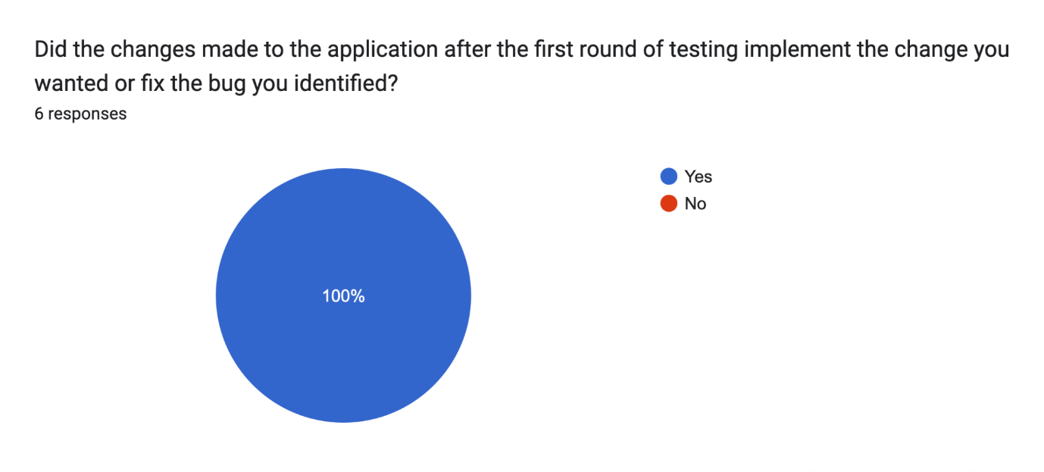

## Finally, we asked them how happy they were with the changes that were made overall.

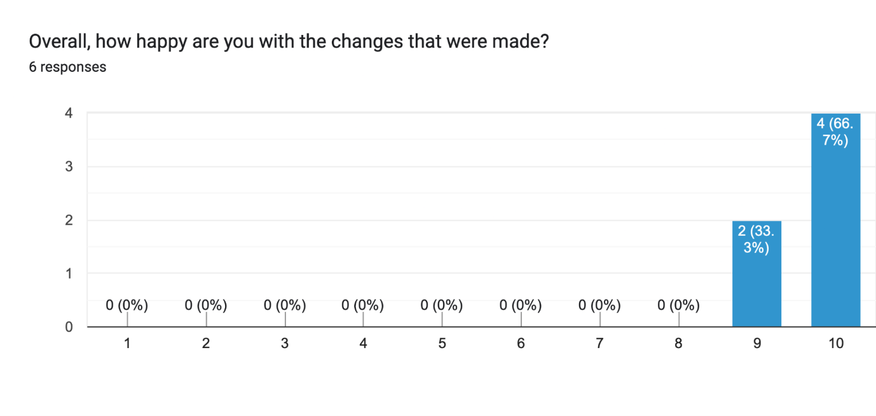

# Testing Conclusion

As seen above, all six testers were happy that their main issues had been fixed in version 0.9.2. Despite other smaller issues, all we very happy with the application where it stands now. The remaining issues that the testers have brought up do not affect the ability to use the application. Ideally, we would have liked to have fixed these issues as well but due to earlier setbacks, as well as the end of semester exam and assignments, we were unable to find the time. We are pleased the app was well received by our testers.